Guided Lab - 303.1.1A - Installation Guide for JDK

Introduction:
In this lab, we will demonstrate how to install JDK on Windows OS and MacOS.

The Java Development Kit (JDK) is helpful for writing programs in Java. It is also known as the Java Platform Standard Edition (Java SE). JDK is an open-source software provided by Sun Microsystems, now taken over by Oracle for anyone to use freely for programming.

Lab Objective:
By the end of this lab, learners should be able install Install JDK

Installation Prerequisites of JDK

JDK has bare minimum requirements for disk space and RAM for the 64-bit Windows platform. It requires approximately 800 MB disk space to install JDK, as JRE also gets installed along with it.

JDK requires 128 MB of memory space to run successfully. This is the minimum RAM required for running basic and small programs, but as the size of an application increases, the memory requirement also increases for the application to run smoothly.

Instructions

Install JDK for Windows OS
Click here for Download Amazon Corretto 8 or later version
- Download a .msi file from the Downloads page.
For Windows operating systems (64-bit), choose to download the installer program (MSI) for JDK:
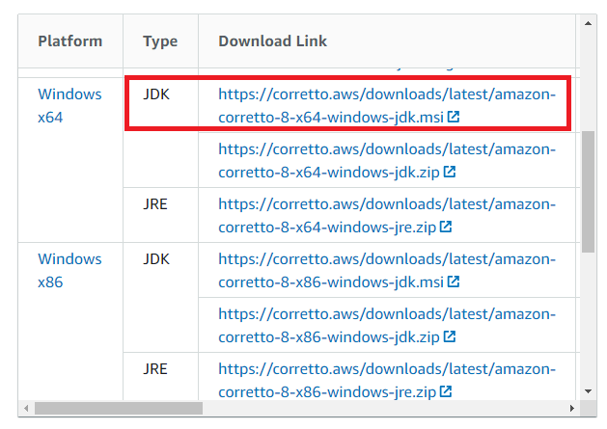
- It will download the amazon-corretto-VERSION-windows-x64.msi file. This is the installer program for Windows, which makes the setup process quick and easy.
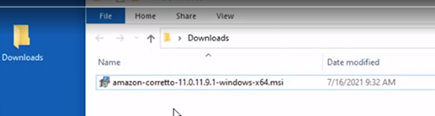
- Double-click the .msi file to start the installation wizard.
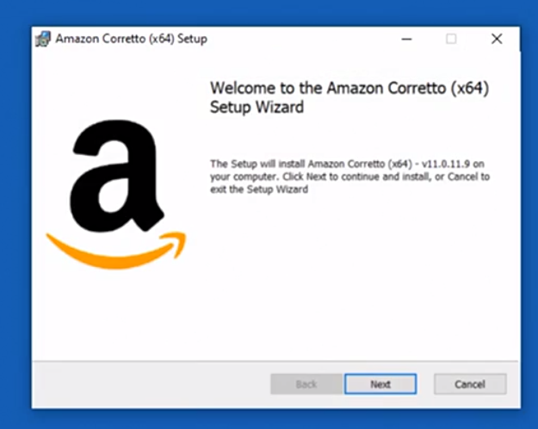
- Click on the Next button, and keep the default options presented below:
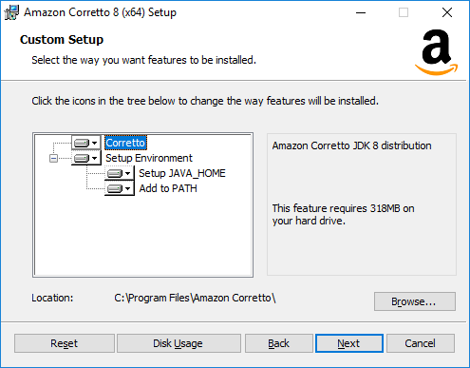
- Click on the Install button.
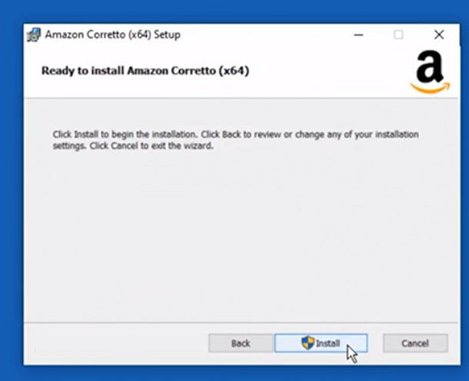
6: After a successful installation, verify the version of your Java by opening the command prompt. Type the code below:
java -version
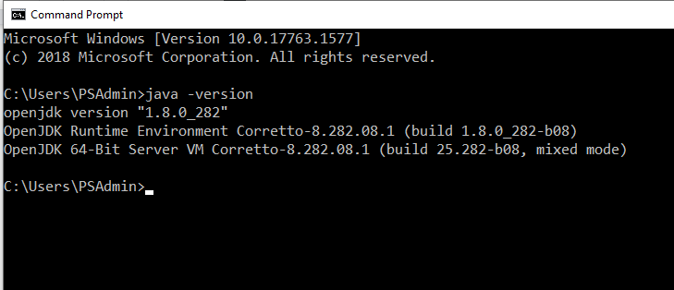

Install JDK on MacOC

macOS 10.10 or later
- Download the Mac.pkg file from the Downloads page.
- Double-click the downloaded file to start the installation wizard. Follow the steps in the wizard.
- Once the wizard completes, Amazon Corretto 8 will be installed in /Library/Java/JavaVirtualMachines/.
- You can run the following command in a terminal to get the complete installation path: /usr/libexec/java_home --verbose
- Optionally, run the following commands in the terminal to set the JAVA_HOME variable:
  - export JAVA_HOME=/Library/Java/JavaVirtualMachines/amazon-corretto-8.jdk/Contents/Home

Additional Resources - Video
Video - How To Install Amazon Corretto JDK 11 On a Mac.
Video - How to Install JDK 11 for Amazon Corretto for Windows.

Resources:
https://docs.aws.amazon.com/corretto/latest/corretto-8-ug/what-is-corretto-8.html
https://www.educba.com/install-jdk/

Submission Instructions:
Include the following deliverables in your submission -
  - Take a screenshot of the installed JDK folder or the version command result (reference step 6).
  - Submit the screenshot using the Start Assignment button in the top-right corner of the assignment page in Canvas.
